**Task #1**

a)

> xx=1:10

> xx

[1] 1 2 3 4 5 6 7 8 9 10

b)

> PP=c(.01,.12,.13,.14,.2,.2,.1,.05,.04,.01)

> PP

[1] 0.01 0.12 0.13 0.14 0.20 0.20 0.10 0.05

[9] 0.04 0.01

c)

sum(PP)

[1] 1

d)

> require(graphics)

> par(mfrow = c(2, 1))

e)

> plot(xx,PP,type = "h", col = 2,main = "Pmf List",xlab = "x",ylab = "p(x)")

> points(xx,PP,col = 2);abline(h=0,col=3)

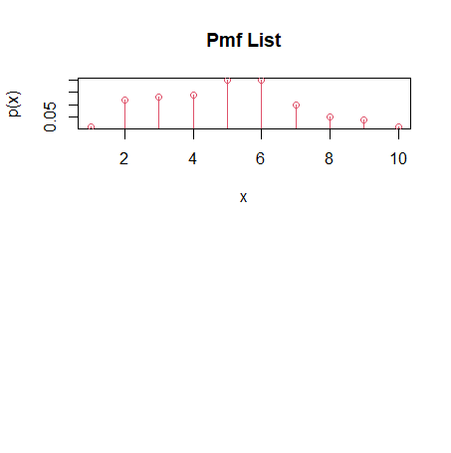

f)

> QQ=cumsum(PP)

> QQ

[1] 0.01 0.13 0.26 0.40 0.60 0.80 0.90 0.95

[9] 0.99 1.00

g)

c(xx,PP,QQ)

[1] 1.00 2.00 3.00 4.00 5.00 6.00 7.00

[8] 8.00 9.00 10.00 0.01 0.12 0.13 0.14

[15] 0.20 0.20 0.10 0.05 0.04 0.01 0.01

[22] 0.13 0.26 0.40 0.60 0.80 0.90 0.95

[29] 0.99 1.00

f)

plot(c(0,xx),c(0,QQ),type = "s",ylab = "F(x)",col = 2, xlab = "x",main = "Cdf

for user defined dist.")

abline(h=0:1,col=4)

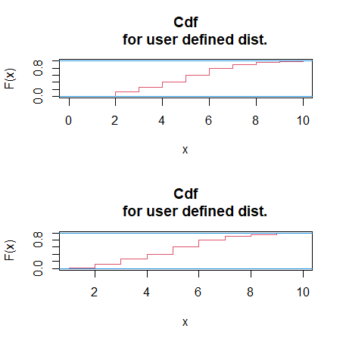

**Task #2**

a)

> xx=1:10

> PP=pbinom(xx,size = 10,prob = .6)

> require(graphics)

> par(mfrow = c(2, 1))

> plot(xx,PP,type = "h", col = 2,main = "Pmf List",xlab = "x",ylab = "p(x)")

> points(xx,PP,col = 2);abline(h=0,col=3)

> QQ=cumsum(PP)

> c(xx,PP,QQ)

[1] 1.000000000 2.000000000 3.000000000 4.000000000 5.000000000 6.000000000 7.000000000

[8] 8.000000000 9.000000000 10.000000000 0.001677722 0.012294554 0.054761882 0.166238618

[15] 0.366896742 0.617719398 0.832710246 0.953642598 0.993953382 1.000000000 0.001677722

[22] 0.013972275 0.068734157 0.234972774 0.601869517 1.219588915 2.052299162 3.005941760

[29] 3.999895142 4.999895142

> plot(c(0,xx),c(0,QQ),type = "s",ylab = "F(x)",col = 2, xlab = "x",main = "Cdf

for user defined dist.")

> abline(h=0:1,col=4)

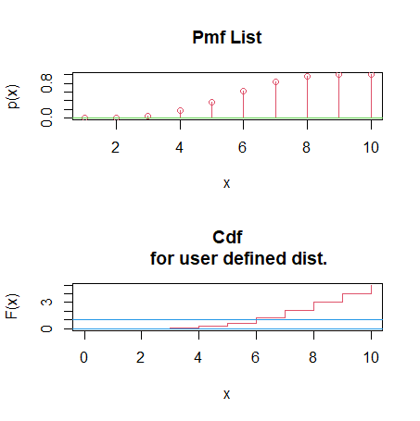

> xx=1:10

> PP=dbinom(xx,size = 10,prob = .6)

> require(graphics)

> par(mfrow = c(2, 1))

> plot(xx,PP,type = "h", col = 2,main = "Pmf List",xlab = "x",ylab = "p(x)")

> points(xx,PP,col = 2);abline(h=0,col=3)

> QQ=cumsum(PP)

> c(xx,PP,QQ)

[1] 1.000000000 2.000000000 3.000000000 4.000000000 5.000000000 6.000000000 7.000000000

[8] 8.000000000 9.000000000 10.000000000 0.001572864 0.010616832 0.042467328 0.111476736

[15] 0.200658125 0.250822656 0.214990848 0.120932352 0.040310784 0.006046618 0.001572864

[22] 0.012189696 0.054657024 0.166133760 0.366791885 0.617614541 0.832605389 0.953537741

[29] 0.993848525 0.999895142

> plot(c(0,xx),c(0,QQ),type = "s",ylab = "F(x)",col = 2, xlab = "x",main = "Cdf

for user defined dist.")

> abline(h=0:1,col=4)

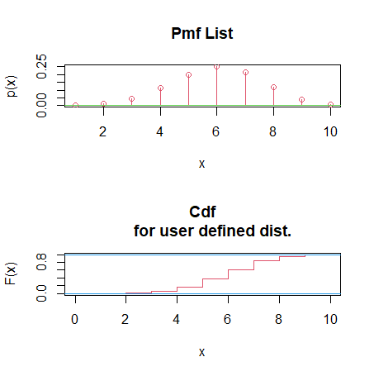

b)

> xx=1:10

> PP=ppois(xx,lambda = 6)

> require(graphics)

> par(mfrow = c(2, 1))

> plot(xx,PP,type = "h", col = 2,main = "Pmf List",xlab = "x",ylab = "p(x)")

> points(xx,PP,col = 2);abline(h=0,col=3)

> QQ=cumsum(PP)

> c(xx,PP,QQ)

[1] 1.00000000 2.00000000 3.00000000 4.00000000 5.00000000 6.00000000 7.00000000 8.00000000

[9] 9.00000000 10.00000000 0.01735127 0.06196880 0.15120388 0.28505650 0.44567964 0.60630278

[17] 0.74397976 0.84723749 0.91607598 0.95737908 0.01735127 0.07932007 0.23052395 0.51558045

[25] 0.96126009 1.56756288 2.31154264 3.15878013 4.07485611 5.03223519

> plot(c(0,xx),c(0,QQ),type = "s",ylab = "F(x)",col = 2, xlab = "x",main = "Cdf

for user defined dist.")

> abline(h=0:1,col=4)

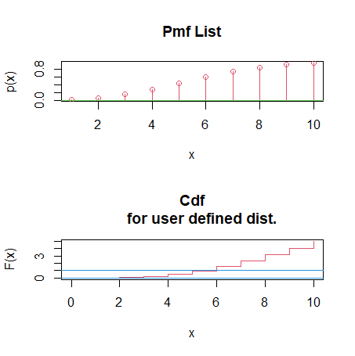

> xx=1:10

> PP=dpois(xx,lambda = 6)

> require(graphics)

> par(mfrow = c(2, 1))

> plot(xx,PP,type = "h", col = 2,main = "Pmf List",xlab = "x",ylab = "p(x)")

> points(xx,PP,col = 2);abline(h=0,col=3)

> QQ=cumsum(PP)

> c(xx,PP,QQ)

[1] 1.00000000 2.00000000 3.00000000 4.00000000 5.00000000 6.00000000 7.00000000 8.00000000

[9] 9.00000000 10.00000000 0.01487251 0.04461754 0.08923508 0.13385262 0.16062314 0.16062314

[17] 0.13767698 0.10325773 0.06883849 0.04130309 0.01487251 0.05949005 0.14872513 0.28257775

[25] 0.44320089 0.60382403 0.74150101 0.84475874 0.91359723 0.95490032

> plot(c(0,xx),c(0,QQ),type = "s",ylab = "F(x)",col = 2, xlab = "x",main = "Cdf

for user defined dist.")

> abline(h=0:1,col=4)

